MBC Connect 2.0 Release Campaign
Twitter Copy for MBCA Members
November 2019 - January 2020

Calendar the numbered posts below to be published on your organization’s Twitter page, according to the schedule noted in your implementation guide.

Post #1: Coming soon!
SHARE FROM MBCA TWITTER PAGE

Go to the MBC Twitter page on November 22nd after 8 am ET and retweet this post to your channel. (Image shown below is for reference only.) The post will be available at the top of the MBCA page for 48 hours.

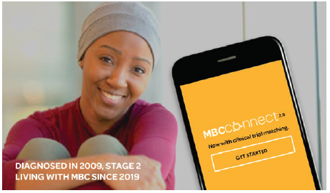

COMING SOON: #MBCconnect 2.0 will make it easy to find #clinicaltrials for #metastaticBC by sending you potential matches. Learn more: http://bit.ly/mbcatw #mBCSM #BCSM

Post #2: Get ready
PHOTO TWEET

Image: get-ready-2.jpg

Copy:
GET READY FOR #MBCCONNECT 2.0! Did you know all new treatments are the result of #clinicaltrials? Our updated patient experience registry will show you potential matches for #metastaticBC trials: http://bit.ly/membtw #MBCresearch

Post #3: It’s here!
SHARE FROM MBCA TWITTER PAGE

Go to the MBC Twitter page on December 2nd after 9 am ET and retweet this post to your channel. (Image shown below is for reference only. )The post will be available at the top of the MBCA page for 48 hours.

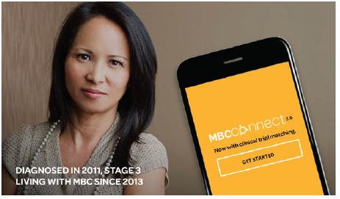

MBC CONNECT 2.0 IS HERE!! Sign up or update your mobile app now to start getting potential matches to #metastaticBC #clinicaltrials, based on your patient info: http://bit.ly/mbcatw #MBCconnect #mBCSM #BCSM

Post #4: Designed by patients, for patients
PHOTO TWEET

Image: by-patients-4.jpg

Copy:
JUST RELEASED! Now there’s an easy way to find #clinicaltrials – using a tool designed by patients, for patients. #MBCconnect 2.0 matches you to #metastaticBC trials that could be right for you. Get started: http://bit.ly/membtw #mBCSM #BCSM

Post #5: Fill out two short surveys
SHARE FROM MBCA TWITTER PAGE

Go to the MBC Twitter page on December 16th after 8 am ET and retweet this post to your channel. (Image shown below is for reference only. )The post will be available at the top of the MBCA page for 48 hours.

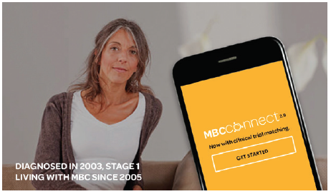

NOW WITH CLINICAL TRIAL MATCHING: Just fill out two short surveys to start getting potential matches to #clinicaltrials for #metastaticBC through #MBCconnect 2.0! Help drive #MBCresearch: http://bit.ly/mbcatw

Post #6: Help advance breakthroughs
PHOTO TWEET

Image: advance-breakthroughs-6.jpg

Copy:
HELP ADVANCE BREAKTHROUGHS: #MBCconnect 2.0’s patient experience registry shows you potential matches to #clinicaltrials for #metastaticBC and lets you share them with your care team: http://bit.ly/membtw #MBCresearch

Post #7: Clinical trials in the palm of your hand
SHARE FROM MBCA TWITTER PAGE

Go to the MBC Twitter page on January 6th after 8 am ET and retweet this post to your channel. (Image shown below is for reference only. )The post will be available at the top of the MBCA page for 48 hours.

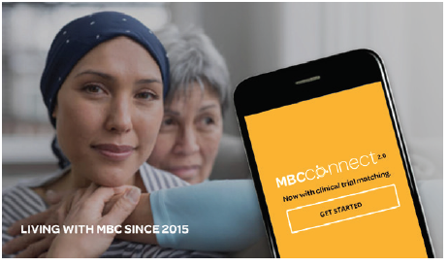

CLINICAL TRIALS, IN THE PALM OF YOUR HAND: Download the #MBCconnect 2.0 app now to get matches to #metastaticBC trials that could be right for you: http://bit.ly/mbcatw #mBCSM #BCSM

Post #8: Join the movement
PHOTO TWEET

Image: join-the-movement-8.jpg

Copy:

JOIN THE MOVEMENT! The #MBCconnect 2.0 patient experience registry can show you potential matches to clinical trials – so you can help drive advances. Get started: http://bit.ly/membtw #MBCresearch

