MBC Connect 2.0 Release Campaign
Facebook Copy for MBCA Members
November 2019 - January 2020

OPTIONAL: Facebook Frame

MBC Connect supporters (including both Alliance members and the general public) can add a Facebook frame to their profile to raise awareness for MBC Connect. To get the frame:

- Go to: https://www.facebook.com/profilepicframes
- Search for: MBC Connect

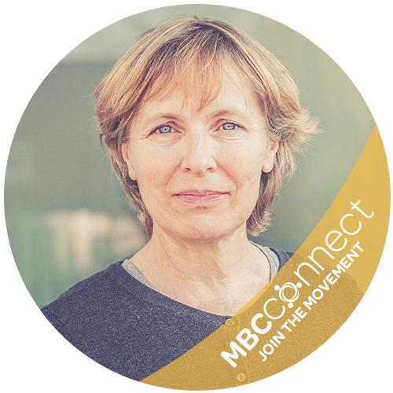

CAMPAIGN: Copy/Directions for 2.0 Release Campaign
Calendar the numbered posts below to be published on your organization’s Facebook page, according to the schedule noted in your implementation guide.

Post #1: Coming soon!
SHARE FROM MBCA FACEBOOK PAGE

Go to the MBCA Facebook page on November 22nd after 8 am ET and share this post to your channel. (Image shown below is for reference only.) The post will be available at the top of the MBCA page for 48 hours.

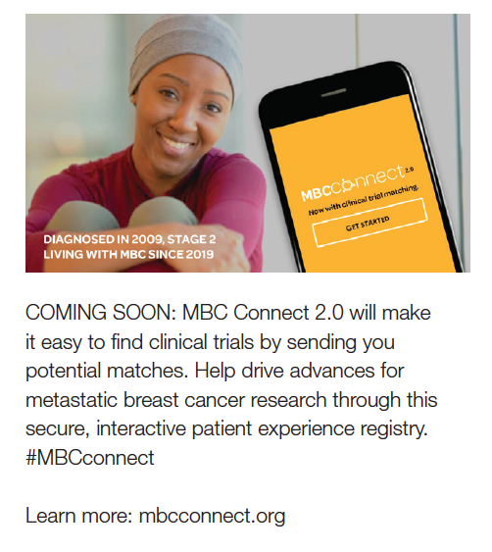

Post #2: Get ready
POST DIRECTLY TO FACEBOOK

Upload image first: get-ready-2.jpg

Then add copy:
GET READY FOR MBC CONNECT 2.0! Did you know all new treatments are the result of clinical trials? Our updated patient experience registry will show you matches for trials that may be right for you. Together, let’s advance metastatic breast cancer research. #MBCConnect

Learn more: http://bit.ly/membfb

Post #3: It’s here!
SHARE FROM MBCA FACEBOOK PAGE

Go to the MBCA Facebook page on December 2nd after 9 am ET and share this post to your channel. (Image shown below is for reference only. )The post will be available at the top of the MBCA page for 48 hours.
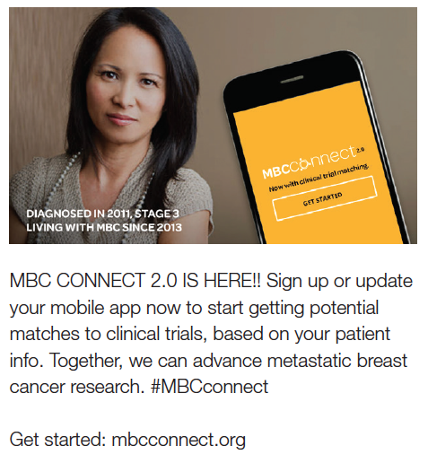

Post #4: Designed by patients, for patients
POST DIRECTLY TO FACEBOOK

Upload image first: by-patients-4.jpg

Then add copy:
JUST RELEASED! Now there’s an easy way to find clinical trials – using a tool designed by patients, for patients. Through MBC Connect 2.0, get matches to metastatic breast cancer trials that could be right for you. Simple language, targeted results, powerful potential. #MBCconnect

Get started: http://bit.ly/membfb

Post #5: Fill out two short surveys
SHARE FROM MBCA FACEBOOK PAGE

Go to the MBCA Facebook page on December 16th after 8 am ET and share this post to your channel. (Image shown below is for reference only. )The post will be available at the top of the MBCA page for 48 hours.
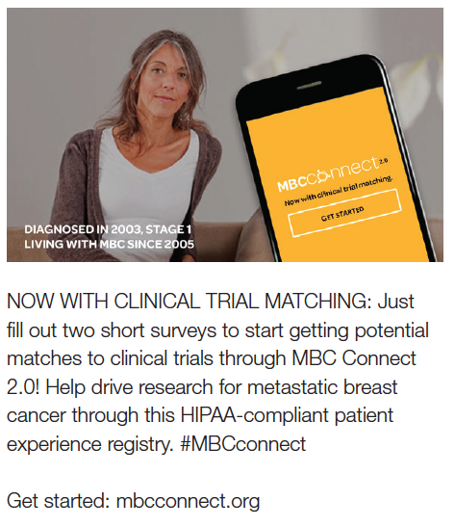

Post #6: Help advance breakthroughs
POST DIRECTLY TO FACEBOOK

Upload image first: advance-breakthroughs-6.jpg

Then add copy:
HELP ADVANCE BREAKTHROUGHS: MBC Connect 2.0’s secure patient experience registry shows you potential matches to clinical trials and lets you share them with your care team. Join today, and help accelerate research on metastatic breast cancer. #MBCconnect

Get started: http://bit.ly/membfb

Post #7: Clinical trials in the palm of your hand
SHARE FROM MBCA FACEBOOK PAGE

Go to the MBCA Facebook page on January 6th after 8 am ET and share this post to your channel. (Image shown below is for reference only. )The post will be available at the top of the MBCA page for 48 hours.
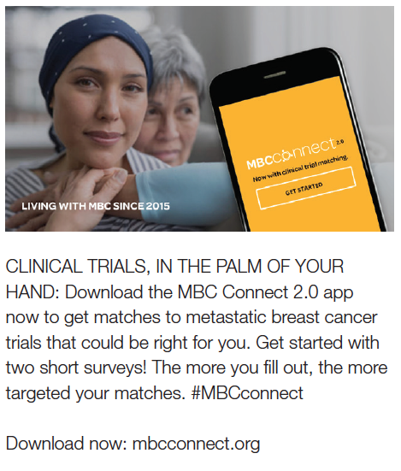

Post #8: Join the movement
POST DIRECTLY TO FACEBOOK

Upload image first: join-the-movement-8.jpg

Then post copy:

JOIN THE MOVEMENT! Now, the MBC Connect 2.0 patient experience registry can show you potential matches to clinical trials – so you can help drive advances. Together, let’s accelerate research on metastatic breast cancer. #MBCconnect

Get started: http://bit.ly/membfb

