CALENDAR

March
 | Su | Mo | Tu | We | Th | Fr | Sa
 |  | 1 | 2 | 3 | 4 | 5 | 6
 |  | Photo Post #1  Pinned to FB & TW  8:30 am |  |  | Video #1  Christine  Pinned to FB & TW  8:30 am
 | 7 | 8 | 9 | 10 | 11 | 12 | 13
 |  | Photo Post #2  Pinned to FB & TW  8:30 am |  |  | Video #2  Deb  Pinned to FB & TW  8:30 am
 | 14 | 15 | 16 | 17 | 18 | 19 | 20
 |  | Photo Post #3  Pinned to FB & TW  8:30 am |  |  | Video #3  Ricki  Pinned to FB & TW  8:30 am
 | 21 | 22 | 23 | 24 | 25 | 26 | 27
 |  | Photo Post 4  Pinned to FB & TW  8:30 am |  |  | Video #4  Sheila  Pinned to FB & TW  8:30 am
 | 28 | 29 | 30 | 31

March 1, 2021 -- PHOTO POST #1
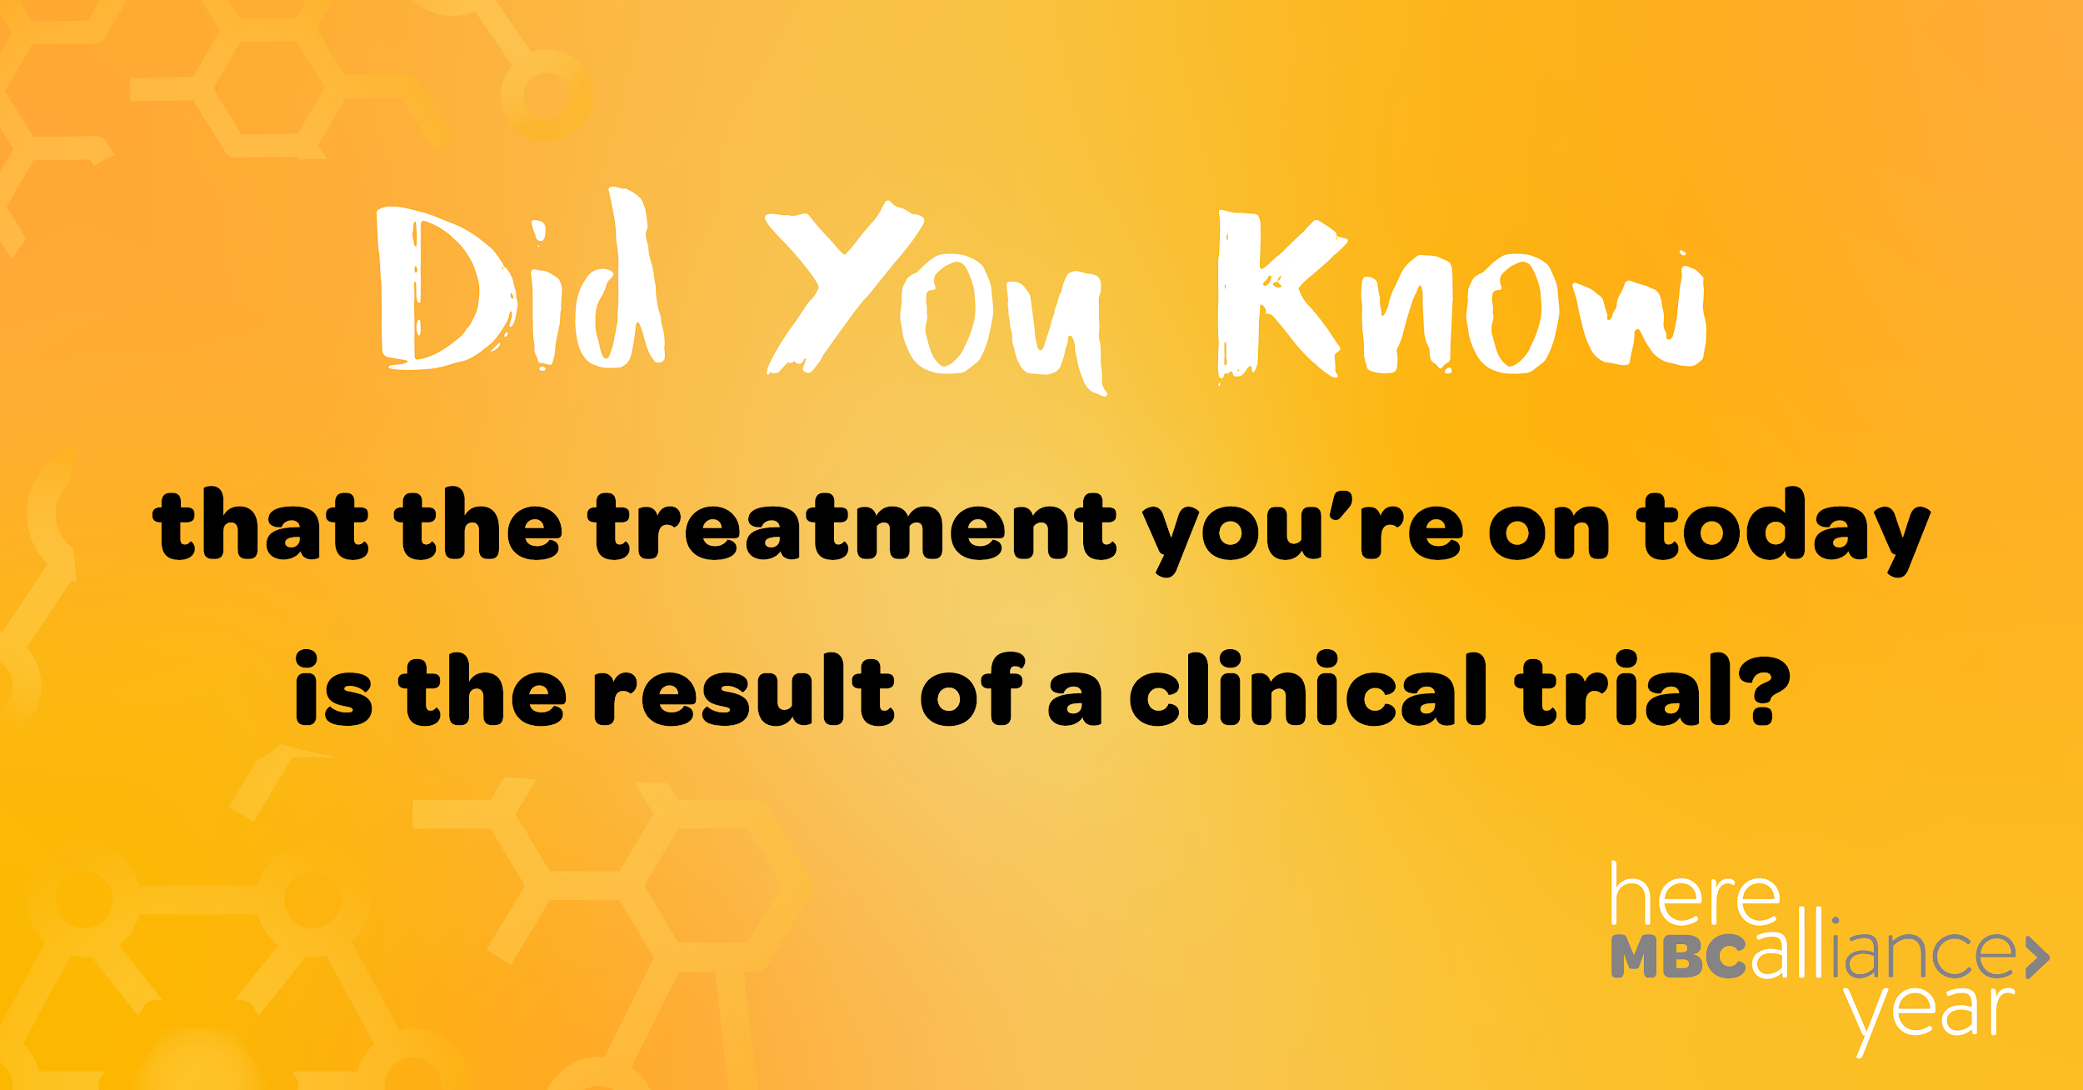 | For your information… NOT for inclusion in social media posts. Posts will direct users to the Here All Year Landing Page where these links will be available.  Image link: https://www.mbcalliance.org/wp-content/uploads/asco_answers_clinical_trials.pdf  LEARN MORE link: https://metastatictrialtalk.org/inside-clinical-trials/clinical-trial-primer/
FACEBOOK
Every month, we’re highlighting a different aspect of Metastatic Breast Cancer to remind everyone that breast cancer awareness matters all year, not just in October. This month, we’re focusing on clinical trials and the critical role they play in MBC research and treatment. Visit our site to learn more, including how to find a clinical trial. https://mbca.me/HAY

TWITTER
Clinical trials play a critical role in breast cancer treatment research. Visit our site to learn more, including how to find a clinical trial. https://mbca.me/HAY #HereAllYear #MBCResearch #BCSM

March 4, 2021—VIDEO POST #1 | Christine Hodgdon
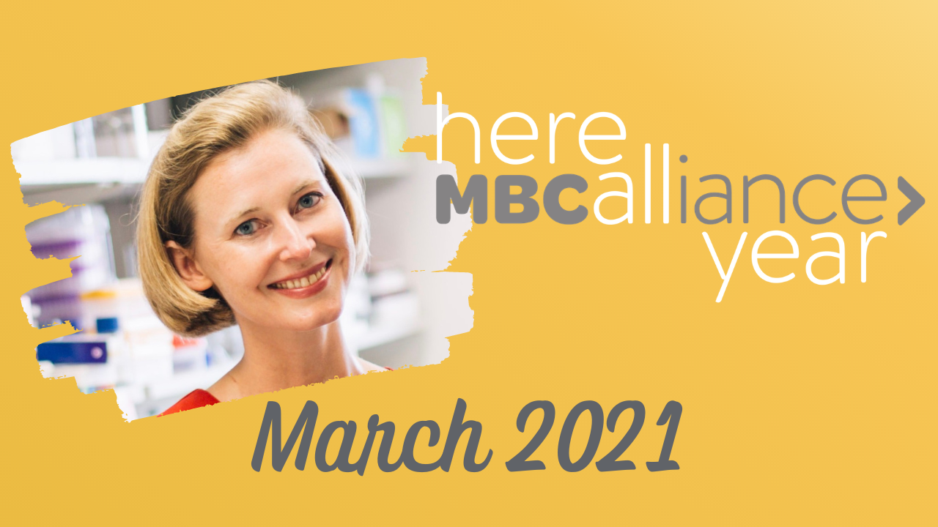 | For your information… NOT for inclusion in social media posts. Posts will direct users to the Here All Year Landing Page where this link will be available.  LEARN MORE link: https://thestormriders.org/science-research/clinical-trials/
FACEBOOK
“The drugs that have saved my life were once being studied in clinical trials.”
Christine Hodgdon was diagnosed with de novo Metastatic Breast Cancer nearly 6 years ago, and she is still on her first line of treatment. She is living with MBC and is a clinical trial patient advocate leader. She launched The Storm Riders Network, which provides a searchable clinical trial database to make it easier for patients to find clinical trials. She is Here All Year: https://mbca.me/HAY

TWITTER
Christine Hodgdon (@christeeny513) was diagnosed with de novo MBC nearly 6 years ago, and she is still on her first line of treatment. She is living with MBC and is a clinical trial patient advocate leader, and she's #HereAllYear. http://mbca.me/Christine #MBCResearch #BCSM
March 8—PHOTO POST #2
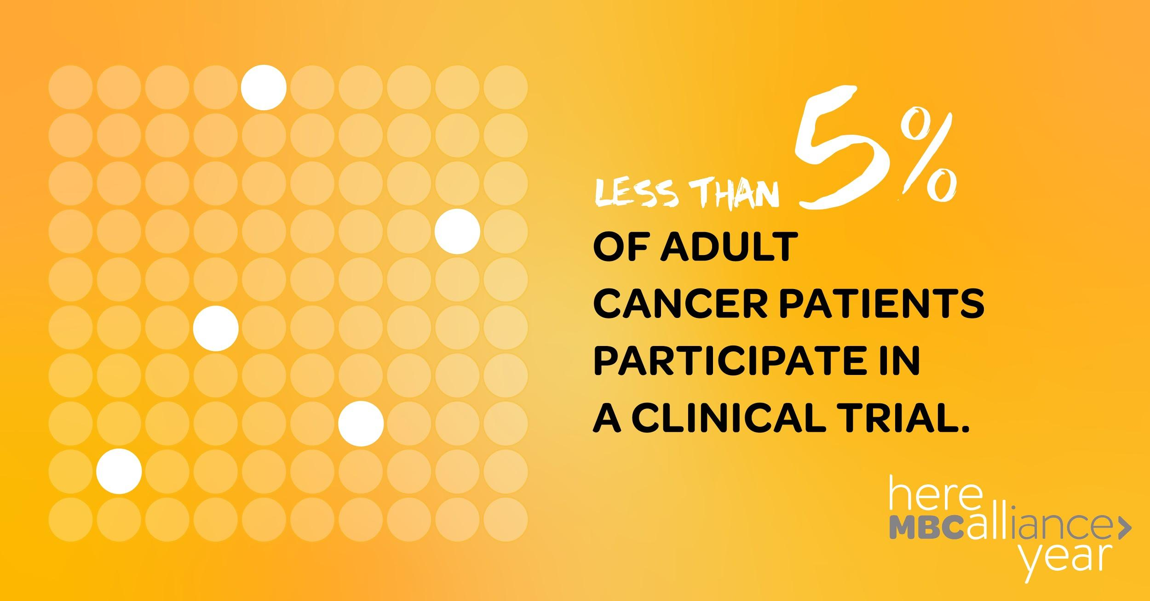 | For your information… NOT for inclusion in social media posts. Posts will direct users to the Here All Year Landing Page where these links will be available.  Image Link: https://www.ncbi.nlm.nih.gov/pmc/articles/PMC5495113/  LEARN MORE link: https://www.asco.org/practice-policy/policy-issues-statements/asco-in-action/asco-and-friends-cancer-research-recommend
FACEBOOK
So few adult cancer patients participate in a clinical trial. Help us change that. Share this post to raise awareness and visit our site to learn more: https://mbca.me/HAY

TWITTER
So few adult cancer patients participate in a clinical trial. Help us change that. Retweet this post to raise awareness and visit our site to learn more: https://mbca.me/HAY #HereAllYear #MBCResearch #BCSM

March 11—VIDEO POST #2| Deb Collyer
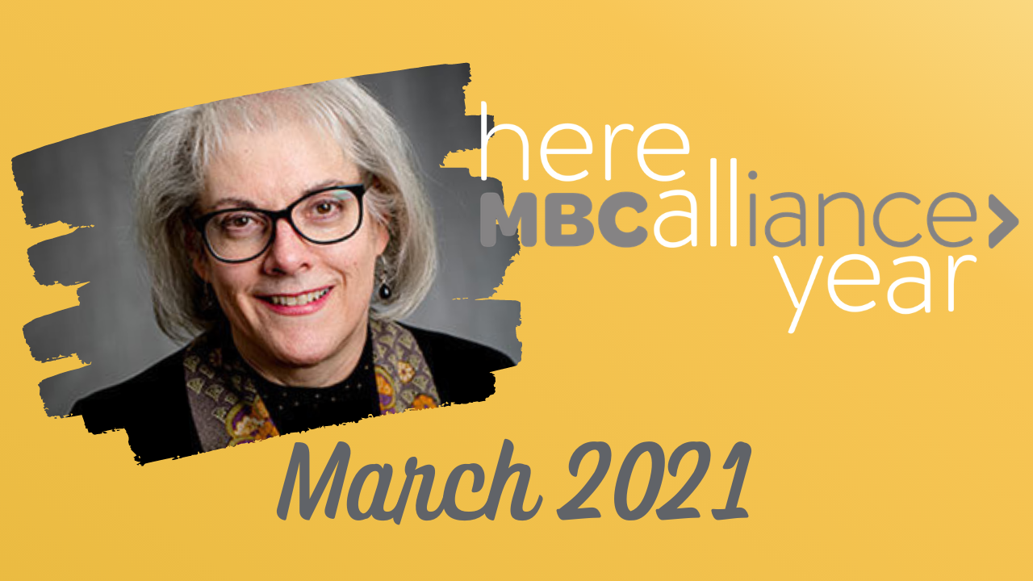 | For your information… NOT for inclusion in social media posts. Posts will direct users to the Here All Year Landing Page where this link will be available.  LEARN MORE link: https://collyar.wordpress.com/
FACEBOOK
“We’re Here All Year, and we’re working to make clinical trials better, and getting better treatments and results for people with cancer.”
Deb Collyar was diagnosed with Stage III breast cancer in the 90s, and has since dedicated her time to being a clinical trial patient advocate leader. She believes in the power of patient advocates and researchers working together to advance progress in cancer research. She’s Here All Year: https://mbca.me/HAY

TWITTER
.@deborahcollyar was diagnosed with Stage III breast cancer in the 90s, and has since dedicated her time to being a clinical trial patient advocate leader. She believes in the power of patient advocates and researchers working together. She’s #HereAllYear: http://mbca.me/Deborah

March 15—PHOTO POST #3
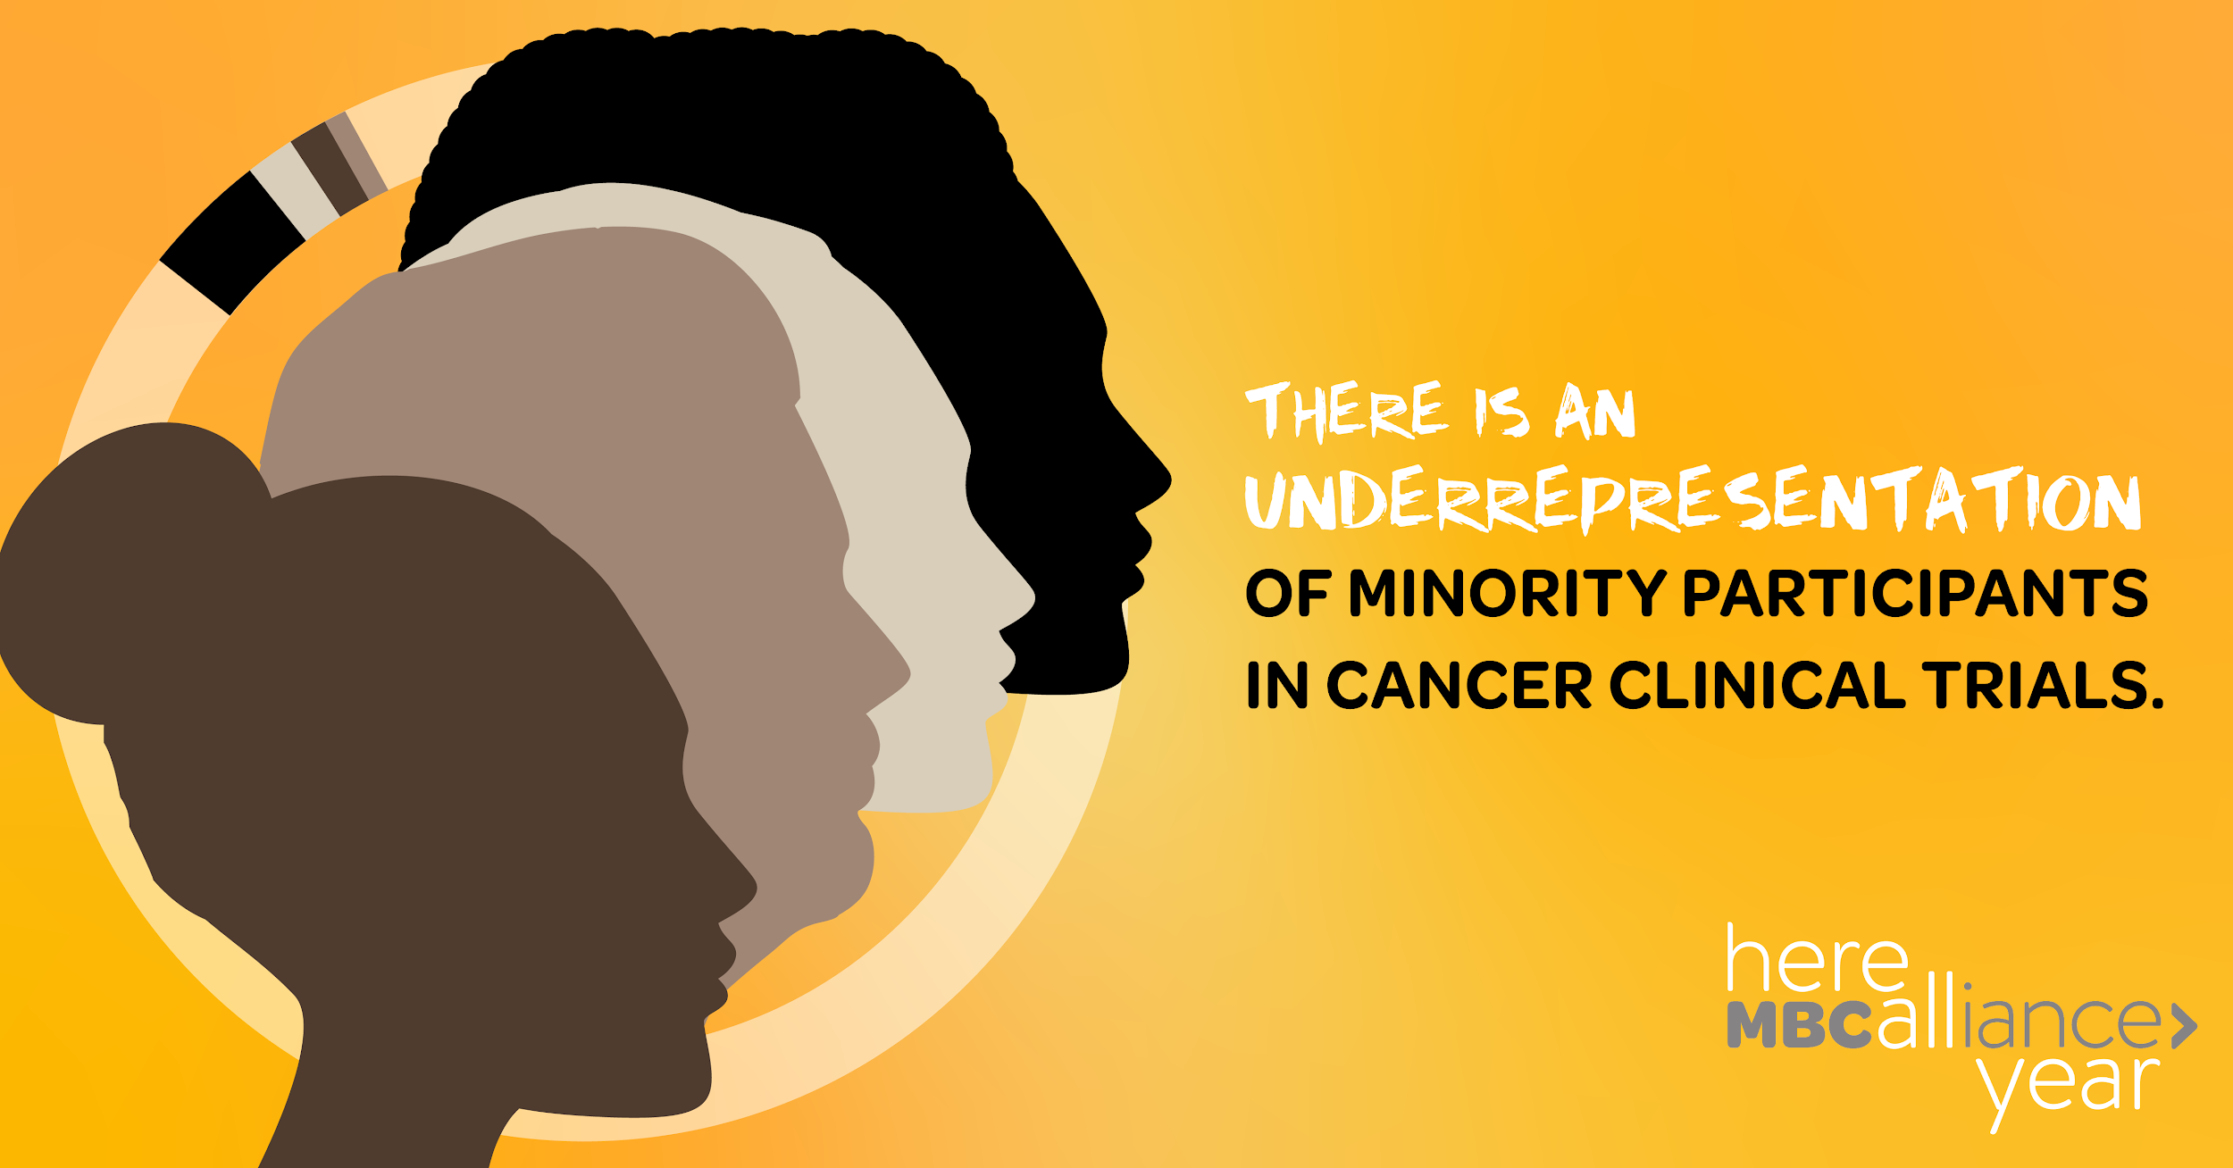 | For your information… NOT for inclusion in social media posts. Posts will direct users to the Here All Year Landing Page where these links will be available.  Image link: https://www.sciencedirect.com/science/article/pii/S0146280618301889?via%3Dihub  LEARN MORE LINK: https://www.ciitizen.com/demystifying-clinical-trials/
FACEBOOK
Did you know that Black people represent only 6.2% of participants in clinical trials? Learn more about why on our site: https://mbca.me/HAY

TWITTER
Did you know that Black people represent only 6.2% of participants in clinical trials? Visit our site to learn more about why this is. https://mbca.me/HAY #HereAllYear #MBCResearch #BlackDataMatters
March 18—VIDEO POST #3 | Ricki Fairley
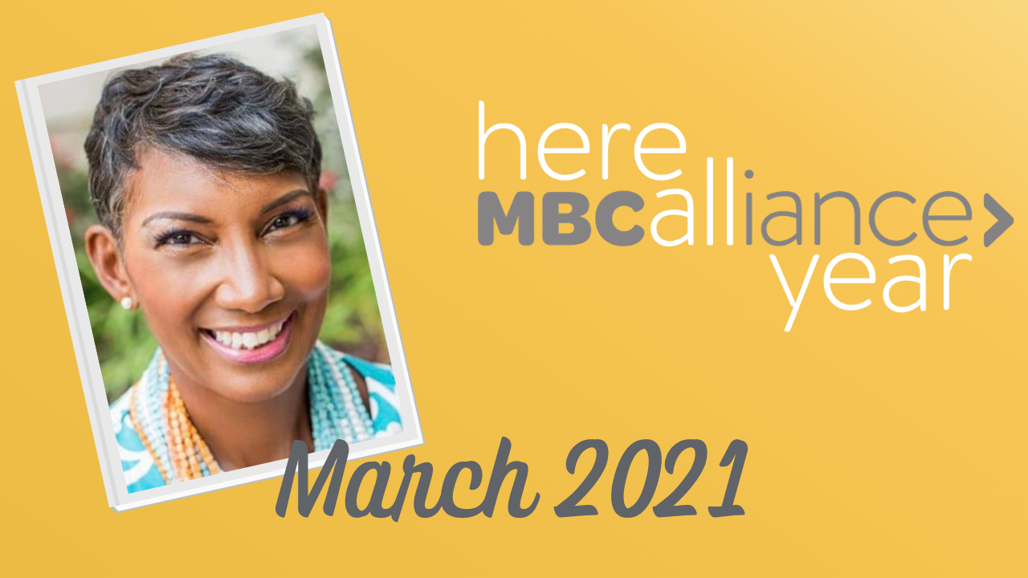 | For your information… NOT for inclusion in social media posts. Posts will direct users to the Here All Year Landing Page where this link will be available.  LEARN MORE link: https://www.touchbbca.org/

FACEBOOK
"The clinical trial conversation for Black women is really the most critical conversation we should be having in breast cancer right now."

Among breast cancer patients, Black women have a 42% higher mortality rate than white women. Ricki Fairley is the CEO of Touch, The Black Breast Cancer Alliance, an organization dedicated to collaborating with stakeholders at every level to work towards the common goal of eradicating Black breast cancer. She is Here All Year. https://mbca.me/HAY

TWITTER
"The clinical trial conversation for Black women is really the most critical conversation we should be having in breast cancer right now." Ricki Fairley, @rickidove, is the CEO of @touchbbca and she’s #HereAllYear: http://mbca.me/Ricki #MBCResearch
March 22—PHOTO POST #4
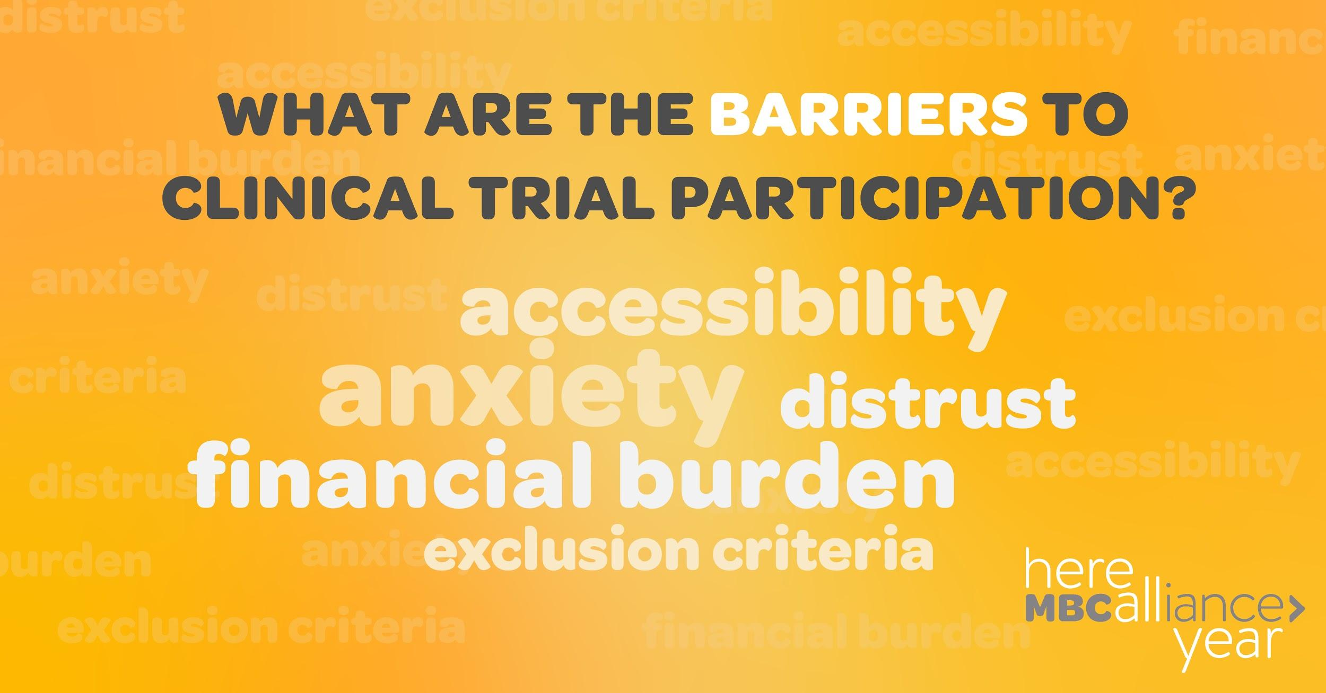 | For your information… NOT for inclusion in social media posts. Posts will direct users to the Here All Year Landing Page where these links will be available.  Image link: https://www.fightcancer.org/policy-resources/clinical-trial-barriers  LEARN MORE link: https://www.fightcancer.org/sites/default/files/National%20Documents/Clinical-Trials-Landscape-Report.pdf
FACEBOOK
95% of adult cancer patients do not participate in a clinical trial due to barriers such as anxiety, lack of accessibility, distrust of the medical community, exclusion criteria, and the financial burden it can place on trial participants. Visit our site to learn more about these barriers and what’s being done to address them: https://mbca.me/HAY

TWITTER
95% of adult cancer patients do not participate in a clinical trial due to barriers such as anxiety, lack of accessibility, and the financial burden it can place on participants. Retweet to raise awareness & learn more at https://mbca.me/HAY. #HereAllYear #MBCResearch

March 25—VIDEO POST #4 | Sheila McGlown
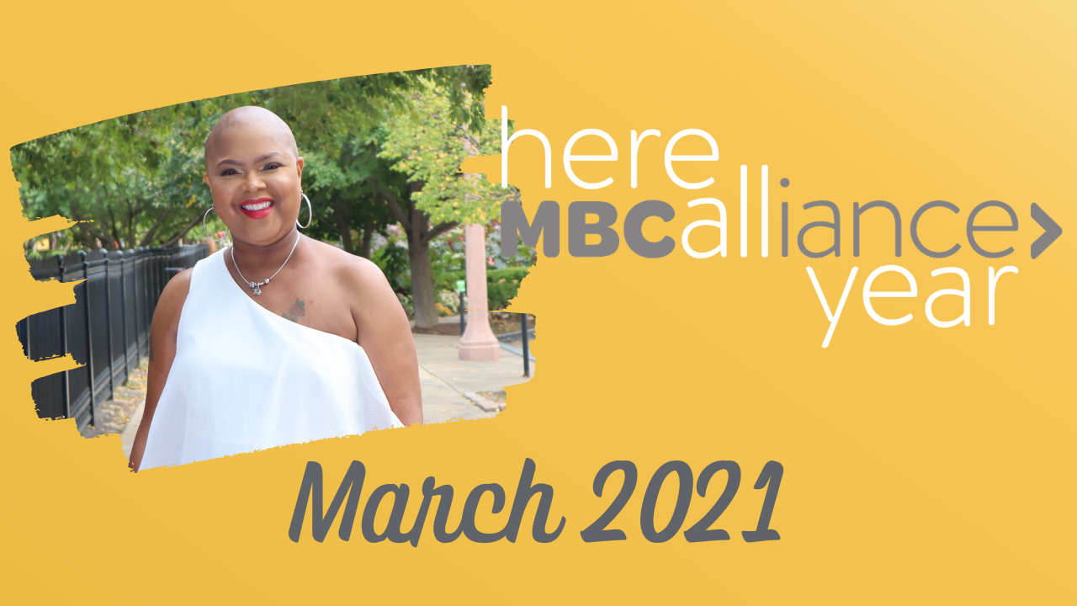 | For your information… NOT for inclusion in social media posts. Posts will direct users to the Here All Year Landing Page where this link will be available.  LEARN MORE link: https://www.storyhalftold.com/meet-sheila-mcglown
FACEBOOK
“I have never known a black woman who has been on a clinical trial until I got on one.”
Sheila McGlown has been living with Metastatic Breast Cancer for 11 years. She’s been on a clinical trial since 2018, and is a strong patient advocate leader for increasing diversity in MBC clinical trials. She’s Here All Year. https://mbca.me/HAY

TWITTER
Sheila McGlown (@swaggsheila1) has been living with Metastatic Breast Cancer for 11 years. She’s been on a clinical trial since 2018, and is a strong advocate leader for increasing diversity in MBC clinical trials. She is #HereAllYear. http://mbca.me/Sheila #MBCResearch

