CALENDAR

January 4—PHOTO POST #1
For your information… NOT for inclusion in social media posts. Posts will direct users to the Here All Year Landing Page where these links will be available.
LEARN MORE link: https://www.mbcalliance.org/here-all-year

FACEBOOK
This month, we’re focusing on cancer subtypes and what that means for your treatment. Visit our site to learn more: https://mbca.me/HAY

TWITTER
This month, we’re focusing on cancer subtypes and what that means for your treatment. Visit our site to learn more: https://mbca.me/HAY #HereAllYear #MBCAlliance #BCSM
January 7—VIDEO POST #1| Lesley Kailani Glenn
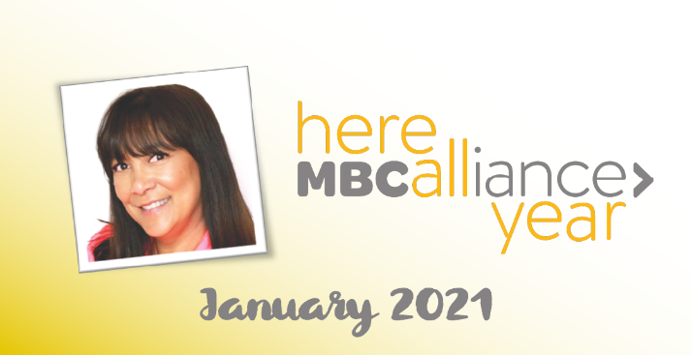 | For your information… NOT for inclusion in social media posts. Posts will direct users to the Here All Year Landing Page where this link will be available.  LEARN MORE link: https://www.facebook.com/projectlifeMBC/
FACEBOOK
Lesley Kailani Glenn was diagnosed with MBC 8 years ago. Watch her testimonial to learn what her MBC subtype means for her treatment: https://mbca.me/LESLEY

TWITTER
Lesley Kailani Glenn was diagnosed with MBC 8 years ago. Watch her testimonial to learn what her MBC subtype means for her treatment: https://mbca.me/LESLEY #HereAllYear #MBCAlliance #BCSM

January 11—PHOTO POST #2
For your information… NOT for inclusion in social media posts. Posts will direct users to the Here All Year Landing Page where these links will be available.
LEARN MORE link: http://mbca.me/NCCN-MBC
Knowing your MBC subtype will help guide your treatment options. Learn more on our site: https://mbca.me/HAY
TWITTER
Knowing your MBC subtype will help guide your treatment options. Visit our site to learn more: https://mbca.me/HAY #HereAllYear #MetastaticBC #BCSM
January 14—VIDEO POST #2 | Victoria Goldberg
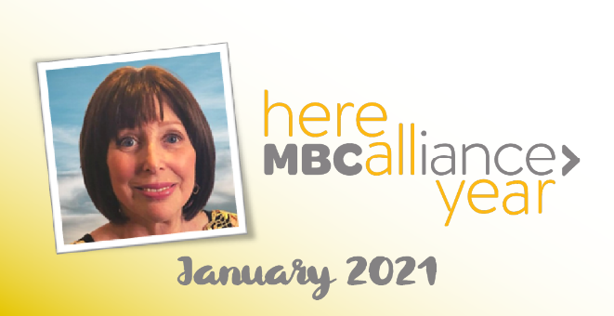 | For your information… NOT for inclusion in social media posts. Posts will direct users to the Here All Year Landing Page where this link will be available.  LEARN MORE link: https://www.ourmbclife.org/about
FACEBOOK
Victoria Goldberg received her first breast cancer diagnosis in 2005 and found out 9 years later that it had progressed to metastatic breast cancer. This is her story, and she’s Here All Year: http://mbca.me/VICTORIA

TWITTER
Victoria Goldberg received her first breast cancer diagnosis in 2005 and found out 9 years later that it had progressed to metastatic breast cancer. This is her story, and she’s #HereAllYear: http://mbca.me/VICTORIA #MBCAlliance

JANUARY 18—PHOTO POST #3
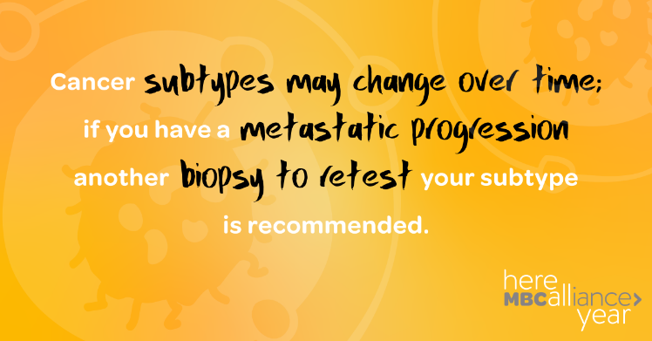 | For your information… NOT for inclusion in social media posts. Posts will direct users to the Here All Year Landing Page where these links will be available.  LEARN MORE link: http://mbca.me/NCCN-MBC
FACEBOOK
Did you know that your MBC molecular subtype can change over time? Share this graphic to raise awareness, and visit our site to learn more: https://mbca.me/HAY

TWITTER
Did you know that your MBC molecular subtype can change over time? Retweet to raise awareness & learn more at https://mbca.me/HAY. #HereAllYear #BCSM #MBCAlliance

BONUS VIDEOS: For social media and YouTube. Please feel free to share the links to the MBCA "Here All Year" Playlist on YouTube.
January 21—VIDEO POST #3 | Joy Jenrette
For your information… NOT for inclusion in social media posts. Posts will direct users to the Here All Year Landing Page where this link will be available.
LEARN MORE link: http://mbca.me/JOY
January 28—VIDEO POST #4 | Ann Jewett
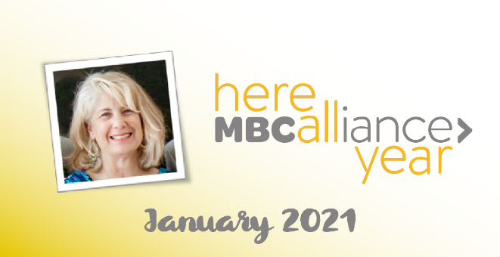 | For your information… NOT for inclusion in social media posts. Posts will direct users to the Here All Year Landing Page where this link will be available.  LEARN MORE link: TBD

