CALENDAR

February
 | Su | Mo | Tu | We | Th | Fr | Sa
 |  | 1 | 2 | 3 | 3 | 5 | 6
 |  | Photo Post #1  Pinned to FB & TW  8:30 am |  |  | Video #1  Stephanie Walker  Pinned to FB & TW  8:30 am
 | 7 | 8 | 9 | 10 | 11 | 12 | 13
 |  | Photo Post #2  Pinned to FB & TW  8:30 am |  |  | Video #2  Shonte Drakeford  Pinned to FB & TW  8:30 am
 | 14 | 15 | 16 | 17 | 18 | 19 | 20
 |  | Photo Post #3  Pinned to FB & TW  8:30 am |  |  | Video #3  Jamil Rivers  Pinned to FB & TW  8:30 am
 | 21 | 22 | 23 | 24 | 25 | 26 | 27
Video #4
Jersi Baker
Pinned to FB & TW
8:30 am
 | 28

February 1—PHOTO POST #1
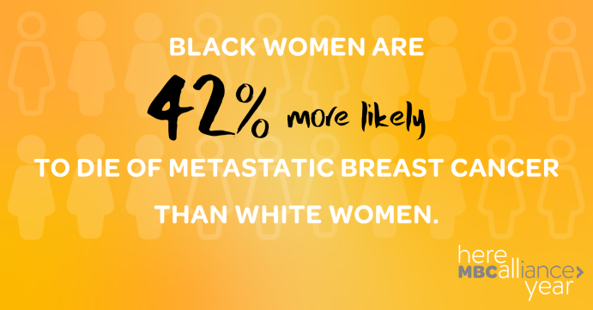 | For your information… NOT for inclusion in social media posts. Posts will direct users to the Here All Year Landing Page where these links will be available.  Image Link: https://www.ncbi.nlm.nih.gov/pmc/articles/PMC5504315/  LEARN MORE link: https://www.touchbbca.org/why-is-black-breast-cancer-different
FACEBOOK
Every month this year, we’re highlighting a different aspect of Metastatic Breast Cancer to remind everyone that breast cancer awareness matters all year, not just in October. This month, we’re focusing on the disproportionate rate at which MBC affects Black women. Share this post to raise awareness and visit our site to learn more: https://mbca.me/HAY

TWITTER
This month, we’re focusing on the disproportionate rate at which Metastatic Breast Cancer affects Black women. Share this post to raise awareness and visit our site to learn more: https://mbca.me/HAY #HereAllYear #MBCAlliance #BCSM #BlackDataMatters
February 4—VIDEO POST #1| Stephanie Walker
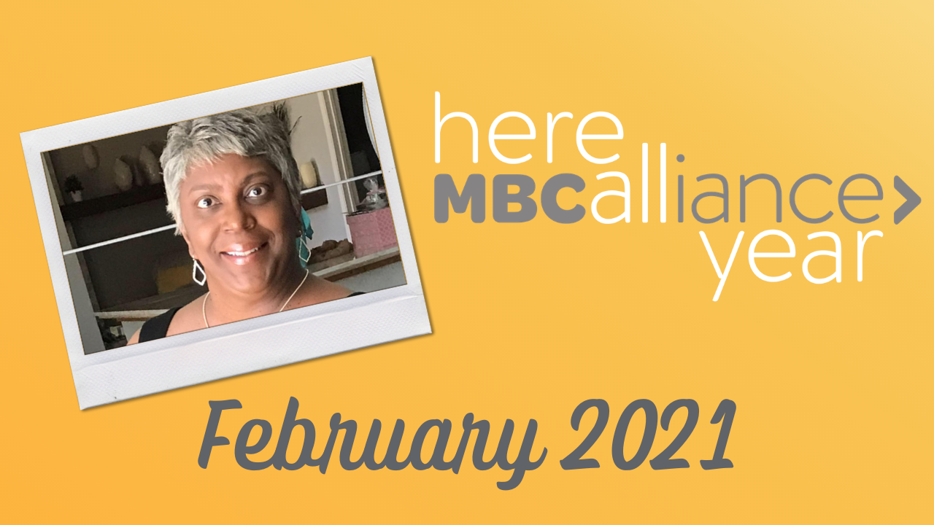 | For your information… NOT for inclusion in social media posts. Posts will direct users to the Here All Year Landing Page where this link will be available.  LEARN MORE link: https://www.lbbc.org/about/about-us/volunteers/stephanie-walker
FACEBOOK
“Don’t I deserve the best care available?” Stephanie Walker received a de novo metastatic breast cancer diagnosis in 2015 and knows that Black women are dying of MBC at a faster rate than white women. This is her story, and she’s Here All Year: https://mbca.me/HAY

TWITTER
“Don’t I deserve the best care available?” Stephanie Walker, @faceofstage4, received a de novo metastatic breast cancer diagnosis in 2015 and knows that Black women are dying of MBC at a faster rate than white women. This is her story, and she’s #HereAllYear: http://mbca.me/Stephanie #MBCAlliance #BCSM

February 8—PHOTO POST #2
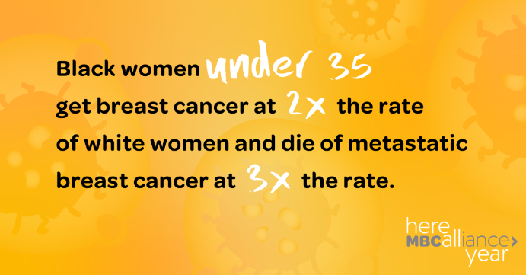 | For your information… NOT for inclusion in social media posts. Posts will direct users to the Here All Year Landing Page where these links will be available.  Image link: https://www.ncbi.nlm.nih.gov/pmc/articles/PMC2894028/  LEARN MORE LINK: https://www.tigerlilyfoundation.org/wp-content/uploads/2016/12/Tigerlily_MY_LIFE_Booklet.pdf
FACEBOOK
Fact: Black women are more likely to be diagnosed with breast cancer at a younger age and later in their disease progression. Learn more on our site: https://mbca.me/HAY
TWITTER
Fact: Black women are more likely to be diagnosed with breast cancer at a younger age and later in their disease progression. Visit our site to learn more: https://mbca.me/HAY #HereAllYear #MetastaticBC #BCSM #BlackDataMatters
February 11—VIDEO POST #2 | Shonte Drakeford
For your information… NOT for inclusion in social media posts. Posts will direct users to the Here All Year Landing Page where this link will be available.
LEARN MORE link: https://www.tigerlilyfoundation.org/stories/shonte-drakeford/

FACEBOOK
“Enjoy life as much as you can, while you can, until you can't.”
Shonte Drakeford was diagnosed with Stage IV Metastatic Breast Cancer on June 17, 2015 via self-discovery. She continues to educate & advocate using the most evidenced based research practices of MBC Cancer care. She is Here All Year: https://mbca.me/HAY

TWITTER
Shonte Drakeford (@shonte19) was diagnosed with Stage IV Metastatic Breast Cancer on June 17, 2015 via self-discovery. She continues to educate & advocate using the most evidenced based research practices of MBC Cancer care. She is #HereAllYear: http://mbca.me/Shonte #MBCAlliance #BCSM
February 15—PHOTO POST #3
For your information… NOT for inclusion in social media posts. Posts will direct users to the Here All Year Landing Page where these links will be available.
Image link: https://www.ncbi.nlm.nih.gov/pmc/articles/PMC3640371/
LEARN MORE link: https://www.breastcancer.org/symptoms/diagnosis/trip_neg
FACEBOOK
More needs to be done to understand why Black women are more likely to be diagnosed with TNBC. Share this graphic to raise awareness, and visit our site to learn more: https://mbca.me/HAY

TWITTER
More needs to be done to understand why Black women are more likely to be diagnosed with TNBC. Retweet to raise awareness & learn more at https://mbca.me/HAY. #HereAllYear #BCSM #MBCAlliance #BlackDataMatters

February 18—VIDEO POST #3 | Jamil Rivers
For your information… NOT for inclusion in social media posts. Posts will direct users to the Here All Year Landing Page where this link will be available.
LEARN MORE link: https://thechrysalisinitiative.org
FACEBOOK
Jamil Rivers was diagnosed with metastatic breast cancer de novo at age 39. She is a patient advocate with the MBC Alliance and volunteers with numerous organizations to advocate for MBC patients, especially Black women. She is Here All Year. https://mbca.me/HAY

TWITTER
Jamil Rivers, @jamilkali, was diagnosed with metastatic breast cancer de novo at age 39. She is a patient advocate with the MBC Alliance and volunteers with numerous organizations to advocate for MBC patients, especially Black women. She is #HereAllYear. http://mbca.me/Jamil #MBCAlliance #BCSM

February 25, 2021—VIDEO POST #4 | Jersi Baker
For your information… NOT for inclusion in social media posts. Posts will direct users to the Here All Year Landing Page where this link will be available.
LEARN MORE link: http://www.angelindisguiseinc.org/

FACEBOOK
Jersi Baker is a metastatic breast cancer patient advocate and President/Founder of Angel in Disguise, a service that provides free transportation for cancer patients in Charlotte, NC. She’s Here All Year: https://mbca.me/HAY

TWITTER
Jersi Baker (@JersiBaker) is a metastatic breast cancer patient advocate and President/Founder of Angel in Disguise, a service that provides free transportation for cancer patients in Charlotte, NC. She’s #HereAllYear: http://mbca.me/Jersi #MBCAlliance #BCSM

