December 1—VIDEO POST #1|
FACEBOOK
For your information… NOT for inclusion in social media posts. Posts will direct users to the Here All Year Landing Page where these links will be available.
LEARN MORE link: https://mbca.me/fda-men
Source document accessible by clicking on the graphic: https://www.fda.gov/media/130061/download
This month, we’re focusing on metastatic breast cancer in men. First, let’s celebrate the good news: Thanks to updated FDA guidelines, more men than ever are being included in clinical trials. Visit our site to learn more: https://mbca.me/HAY
TWITTER
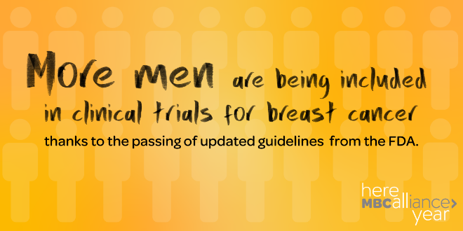
Let’s celebrate the good news: Thanks to updated FDA guidelines, more men than ever are being included in clinical trials. Visit our site to learn more: Visit our site to learn more: https://mbca.me/HAY #HereAllYear #MBCAlliance #BCSM
December 3—VIDEO POST #1|
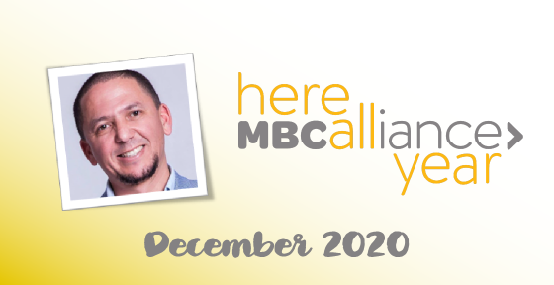 | For your information… NOT for inclusion in social media posts. Posts will direct users to the Here All Year Landing Page where this link will be available.  LEARN MORE link: https://malebreastcancercoalition.org/Survivor Stories/antonio-venturini/
FACEBOOK
Antonio was diagnosed with Metastatic Breast Cancer at the age of 39. "There's not enough done to create awareness around this particular disease in men. I'm living with male breast cancer all year round, not just in October." This is his story, and he's Here All Year. https://mbca.me/Antonio
TWITTER
Antonio was diagnosed with MBC at the age of 39. "There's not enough done to create awareness around this particular disease in men. I'm living with male breast cancer all year round, not just in October." This is his story, and he's #HereAllYear. #MenHaveBreastsToo #BCSM
DECEMBER 7—PHOTO POST
FACEBOOK
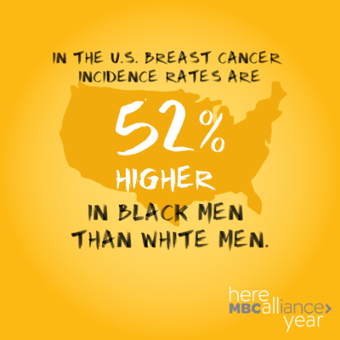 | For your information… NOT for inclusion in social media posts. Posts will direct users to the Here All Year Landing Page where these links will be available.  LEARN MORE link: https://www.cancer.net/cancer-types/breast-cancer-men/statistics  Source document accessible by clicking on the graphic: https://academic.oup.com/jncics/article/4/1/pkz091/5645198
Fact: Men get breast cancer, too. Another Fact: Black men have a much higher rate of breast cancer!
Share this graphic to raise awareness, and visit our site to learn more: https://mbca.me/HAY
TWITTER
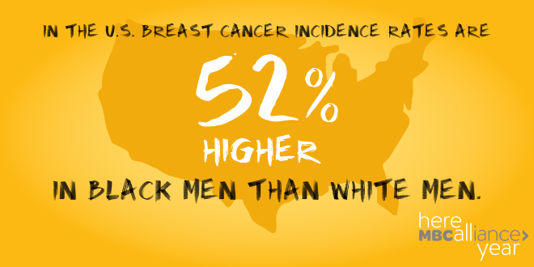
Fact: Men get breast cancer, too. Another Fact: Black men have a much higher rate of breast cancer! Retweet to raise awareness & learn more at https://mbca.me/HAY. #HereAllYear #MenHaveBreastsToo #BCSM #MBCAlliance
DECEMBER 10—VIDEO POST | AMBROSE KIRKLAND
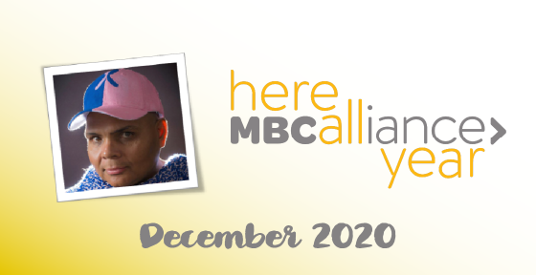 | For your information… NOT for inclusion in social media posts. Posts will direct users to the Here All Year Landing Page where this link will be available.  LEARN MORE link: https://malebreastcancercoalition.org/Survivor%20Stories/ambrose-kirkland-2/
FACEBOOK
“Not only can women pass breast cancer [genetic mutations] on to their daughters, but guess what? Men can also pass breast cancer [genetic mutations] on to their sons.” This is Ambrose’s MBC story. He’s Here All Year. https://mbca.me/Ambrose
TWITTER
“Not only can women pass breast cancer on [genetic mutations] to their daughters, but guess what? Men can also pass breast cancer on to their sons.” This is Ambrose’s MBC story. He’s #HereAllYear https://mbca.me/Ambrose #MBCAlliance
DECEMBER 14—PHOTO POST
FACEBOOK
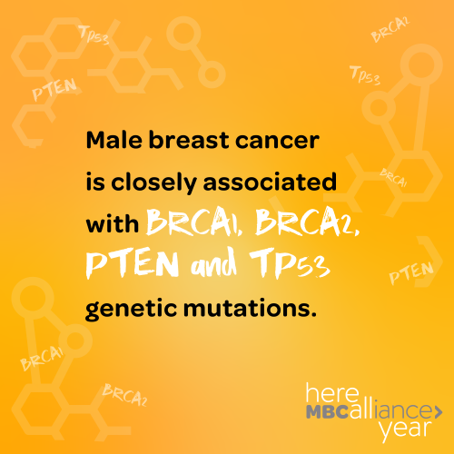 | For your information… NOT for inclusion in social media posts. Posts will direct users to the Here All Year Landing Page where these links will be available.  LEARN MORE link: https://www.cancer.net/cancer-types/breast-cancer-men/risk-factors  Source document accessible by clicking on the graphic: https://breast360.org/topic/2016/10/27/male-breast-cancer-myths-and-facts/
About 1 out of 5 men who develop breast cancer has a family history of the disease. These genetic mutations increase the risk of developing breast cancer. Share this graphic to raise awareness, and visit our site to learn more: https://mbca.me/HAY
TWITTER
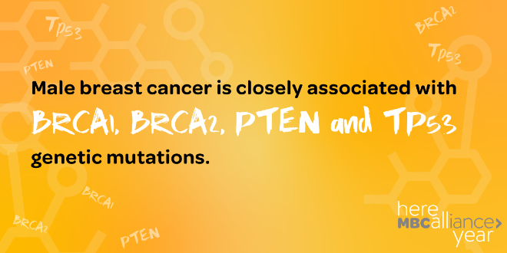
About 1 out of 5 men who develop breast cancer has a family history of the disease. Share this graphic to raise awareness, and visit our site to learn more: https://mbca.me/HAY #HereAllYear #MetastaticBC
DECEMBER 17—VIDEO POST
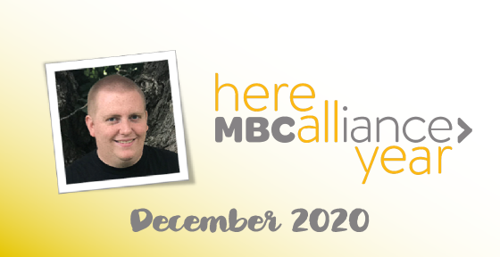 | For your information… NOT for inclusion in social media posts. Posts will direct users to the Here All Year Landing Page where this link will be available.  LEARN MORE link: https://malebreastcancercoalition.org/Survivor%20Stories/eric-pieszala/
FACEBOOK
Eric was diagnosed with Metastatic Breast Cancer in 2019. He's finding success with treatments and found support from his family, coworkers, and other men diagnosed with MBC. He wants everyone to know he's Here All Year. https://mbca.me/Eric
TWITTER
Eric was diagnosed with Metastatic Breast Cancer in 2019. He's finding success with treatments and found support from his family, coworkers, and other men diagnosed with MBC. He’s #HereAllYear. https://mbca.me/Eric #MenHaveBreastsToo

